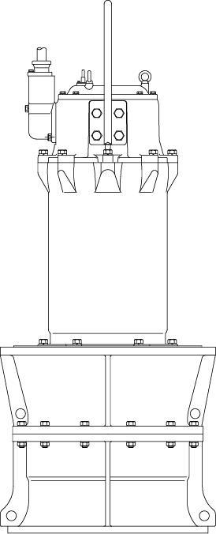

PRODUCT BULLETIN
MODEL SAF SUBMERSIBLE AXIAL FLOW
Bulletin 330SAF
Edition 1

The SAF heavy duty submersible propeller product has been designed to give you what you want, a durable, high flow, submersible pump, all designed to give you long life. The pump features a high efficiency motor, an epoxy resin sealed cable base, an overload “Auto-Cut” motor protector and oil lubricated double mechanical seals.

Material Specifications
PART | CAST IRON FITTED
Casing | Cast Iron
Propeller | Bronze
Shaft | Stainless Steel
Motor Housing | Cast Iron
Bolts, Studs & Nuts | Satinless Steel
Mechanical Seal | Carbon/Ceramic  Carbon/Si-Carbide

MODEL SAF SPECIFICATIONS

Casing: The casing is constructed of high tensile cast iron. It is of the diffuser type, carefully and accurately proportioned to permit smooth flow and to convert high velocity energy of the fluid as it leaves the impeller into pressure.

Propeller: The propeller is casted in one piece of bronze material. to increased life. Enclosed impellers feature large solids passing design and high efficiency. All impellers are dynamically balanced prior to assembly.

Shaft: The shaft is of high strength 420 stainless steel, ground to accurate dimensions and polished to a smooth surface. It is designed for extra stiffness to avoid all critical speeds in operation.

Rear Cover: The rear cover is constructed of cast iron or other specified material. The rear cover houses the double mechanical seal which has a Carbon/Cermanic motor side and Carbon/Silicon-Carbide pump side face arrangement. Both mechanical seals are of the oil lubricated type to provide excellent lubricating fluid for the seal faces. All seal hardware is located in the oil lubricated seal housing, eliminating potential issues with foreign matter clogging the mechanical seal springs. An oil seal is located just outside of the seal chamber housing, adding a third seal to the pump assembly, which eliminated large solid matter from contacting the outside seal face assembly.

Motor: The motor housing frame is constructed of high tensile cast iron and provides support for the windings, shaft and bearing housing. All American-Marsh submersible motors are air filled for ease in servicing, lower running temperatures and feature Class F insulation. Air filled motors have the advantage of being easier to service due to the fact that the large volume of oil required for operation is not present. Larger motor horsepowers feature a cooling jacket on the motor housing, which lowers operating temperatures and extends motor life. These motors feature a motor overload design that protects the motor from high amperage draw, locked impeller and high temperature issues within the pumping assembly. The cable base of the motor has a compression fitting, an epoxy sealed housing, stripped back motor leads (to prevent wicking of moisture) and o-ring construction to prohibit mousture from entering the motor housing. On larger horsepower frame sizes, a moisture leakage detector is included standard for ultimate protection.
PRODUCT BULLETINMUNICIPALCOMMERCIALINDUSTRIAL
MODEL SAF SUBMERSIBLE Submersible Sewage, Heavy SolidsBuilding Waste,Residential,Process Solids, Industrial
AXIAL FLOWStorm WaterWaste

Bulletin 330SAF
Edition 1

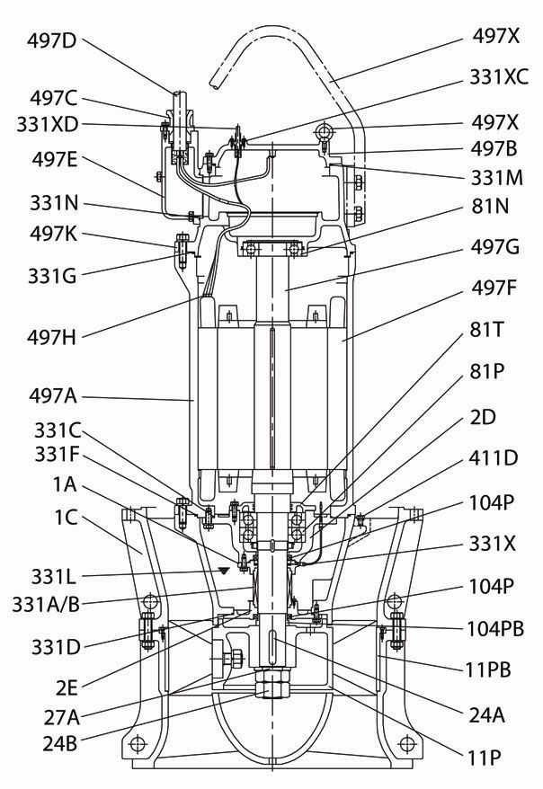

SAF Sectional Drawing

Item Number | Item Description | Num. Req. |  | Item Number | Item Description | Num. Req.
1A | Casing | 1 |  | 331G | Upper Housing Cover O-Ring | 1
1C | Casing Cover | 1 |  | 331L | Mechanical Seal Lubricant | 1
2D | Mechanical Seal Bracket | 1 |  | 331M | Upper Housing Cover O-Ring | 1
2E | Bearing Bracket | 1 |  | 331N | Motor Lead Base O-Ring | 1
11P | Impeller | 1 |  | 331X | Mechanical Seal Moisture Sensor | 1
11PB | Impeller Liner | 1 |  | 331XC | Mech. Seal Moisture Cable Base | 1
24A | Impeller Key | 1 |  | 331XD | Mech. Seal Moisture Sensor Cable | 1
24B | Impeller Locknut | 1 |  | 411D | Oil Plug | 2
27A | Impeller Lockwasher | 1 |  | 497A | Motor Housing | 1
81N | Outboard Bearing | 1 |  | 497B | Upper Housing Cover | 1
81P | Inboard Bearing | 1 |  | 497C | Motor Lead Base Cover | 1
81T | Inboard Bearing Thrust Plate | 1 |  | 497D | Motor Lead | 1
104P | Oil Lip Seal Bushing | 1 |  | 497E | Motor Lead Base | 1
104PB | Oil Lip Seal | 1 |  | 497F | Stator | 1
331A | Mechanical Seal (Motor Side) | 1 |  | 497G | Shaft (with Rotor) | 1
331B | Mechanical Seal (Pump Side) | 1 |  | 497H | Motor Overload Protection | 1
331C | Motor Housing O-Ring | 1 |  | 497K | Motor Housing Upper Cover | 1
331D | Mechanical Seal Bracket O-Ring | 1 |  | 497X | Stainless Steel Eyehook | 3
331F | Casing O-Ring | 1
Recommended spare parts are in BOLD.

